STAT301 Homework 6 Name
- A researcher would like to test the effects of two drugs (A and B) on treating Breast cancer. The researcher recruited 10 patients and assigned drug A randomly to 5 of them and drug B to the other 5. The researcher measured the Oncotype DX score to those 10 patients at three times: Immediately after taking the drugs, 1 year after the drugs, and 5 years after. The Oncotype DX score of 15 or below means that no or low recurrence risk, the score of 21-25 means a medium risk of recurrence, and the score of 26-100 means a high risk of recurrence. Use the 0.05 significance level to test if there is a significant mean score difference between drug A and B, and if there is a significant mean score difference between the three times, and if there is a significant interaction between drug and time.
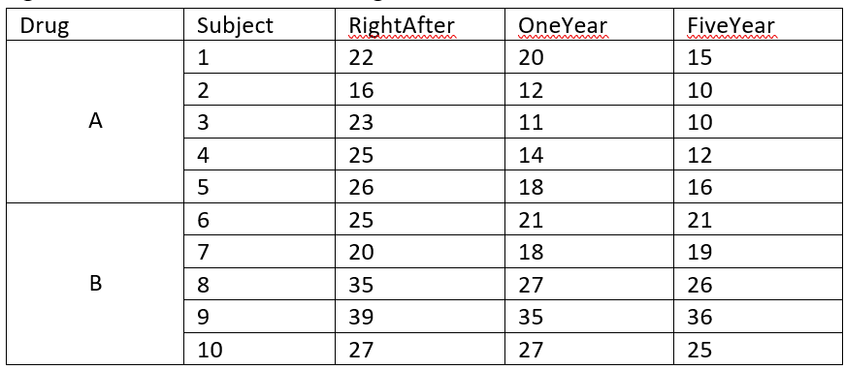
- What type of design is this?

- Formulate the null and alternative hypotheses for testing the main effect of drug using symbols.

- What is the F statistic and p-value testing the main effect of drug?

- What conclusion can you make based on the p-value in b)?

- Formulate the null and alternative hypotheses for testing the main effect of time using symbols.

- What is the F statistic and p-value for testing the main effect of time?

- What conclusion can you make about whether there is a significant mean score difference between the three times?

- Is there a significant interaction between time and drug? What is the p-value for that?
- If there is a significant interaction, we need to separate the data file. Please separate the data by timing:
  - For the timing of Right After, is there a significant mean score difference between drug A and B? What is that p-value?

  - For the timing of One year after, is there a significant mean score difference between drug A and B? What is that p-value?

  - For the timing of Five year After, is there a significant mean score difference between drug A and B? What is that p-value?

- A physician would like to see if different doses of two drugs A and B have significantly different effect on reducing headache. The physician recruited 10 patients and randomly assigned drug A to 5 of them and B to the other five. The physician prescribed one pill for the low dose and two pills for the high dose and asked the patients to take the low dose first and measured their pain scores after, and then to take the high dose and measured their pain scores after. The higher score, the more pain. Use the 0.05 significance level to test if there is the pain scale is significantly different between drug A and B, between the high and low doses, and if there is a significant interaction between the type of drug and the dose.
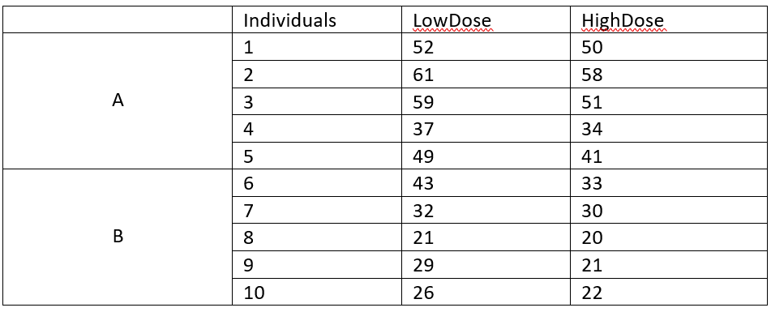
- What type of design is this?

- What is the F statistic and p-value for comparing the drug A and B?

- What conclusion can you make based on the p-value in a)?

- What is the F statistic and p-value for comparing the high and low dosage?

- What conclusion can you make based on the p-value in c)?

- What is the F statistic and p-value for the interaction? Is there a significant interaction?

- Food scientists would like to test the difference of pasta’s taste while cooking under different temperature and different cooking time. They designed the experiment to cook 16 plates of pasta, with 4 under high temperature and long cooking time, 4 under high temperature and short cooking time, 4 under medium temperature and long cooking time, and 4 under medium temperature and short cooking time. At the end of the experiment, they measured the taste scores of the 16 plates of pasta. The higher score, the better pasta. Use the 0.05 significance level to compare if there is a significant difference cooking under the two temperature levels, and with the two different time, and if there is a significant interaction between temperature and time. The data of taste scores is here:
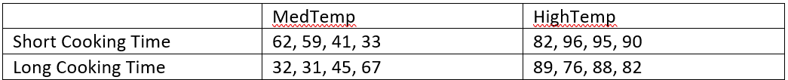
- What type of design is this? (Note this was from one of our previous class)

- Formulate the null and alternative hypotheses for comparing the mean scores between the short and long cooking time

- What is the test statistic and p-value for a)?

- What conclusion can you draw based on the p-value in b)?

- What is the test statistic and p-value for comparing the mean scores between the medium and high temperature levels?

- What conclusion can you draw based on the p-value in d)?

- Is there a significant interaction between cooking time and temperature? What is the p-value?

- The researcher would like to know the effects of pedagogy A and B on improving students’ performance in reading. He recruited 8 students. He trained all 8 students with A and measured their performance in month 1 and then month 2. He then trained all of them with B and measured their performance in a different test in month 1 and the month 2. The data is below. Use the 0.05 significance level to test the main effect of pedagogy and main effect of time, and the interaction.
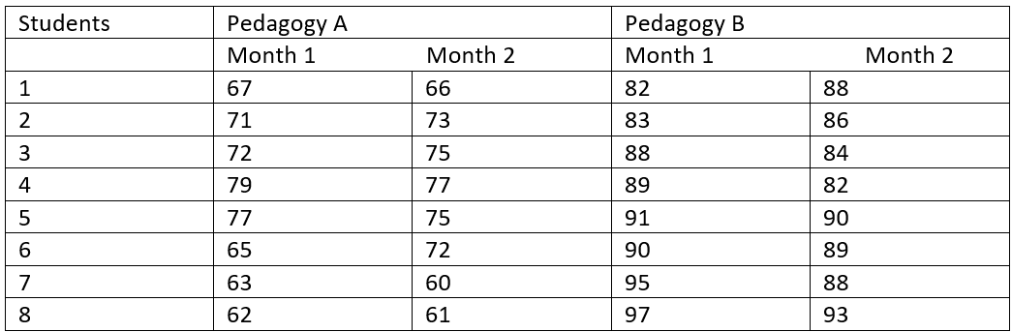
- What is the design?

- What is the test statistic and p-value for comparing the pedagogies?

- What conclusion can you make with the p value in b)?

- What is the test statistic and p-value for comparing the timing?

- What conclusion can you make with the p-value in d)?

- What is the p-value for testing the interaction? Is the interaction significant?

- An online retailer wants to get the best from its employees, as well as improving their working experience. Currently, employees in the retailer’s order fulfilment center are not provided with any kind of entertainment whilst they work (e.g., no background music). However, the retailer wants to know whether providing music, which a few employees have requested, would lead to greater productivity. He recruited a sample of 15 volunteers and split them into three treatment groups: a) a control group that didn’t listen to music; b) a treatment group who listened to music but had no choice of what they listened to; and c) a second treatment group who listened to music and had a choice of what they listened to. The data of their productivities is provided on D2L. The data is not normally distributed. Use the 0.05 significance level to test that if there is any significant difference in their productivities among the three groups.
Step 1: State the null and alternative hypotheses in symbols

Step 2: Choose _______________________________ test

Step 3: What is the test statistic and p-value from R?

Step 4: State your decision to H0 and explain the decision in the context.

